

**Excel Assignment - 15**

Dataset:

https://docs.google.com/spreadsheets/d/1IRSEnmgz8Ro276- GslknRNk0zlrB5CZH1YrnT71kqFM/edit?usp=sharing

Use the above dataset and answer the following questions.

1. Create a Pivot table and show what the main export product is?

Answer:

2. Create a bar graph showing the amount spent for each product?

Answer: 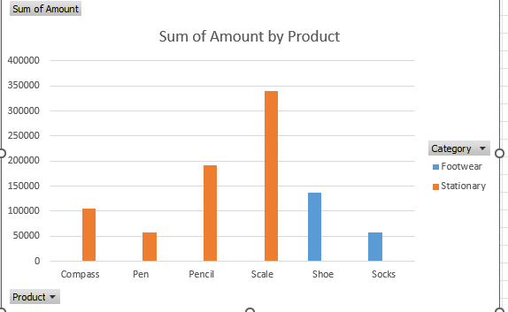

3. Create a Pivot table to show The sales in each city

Answer:

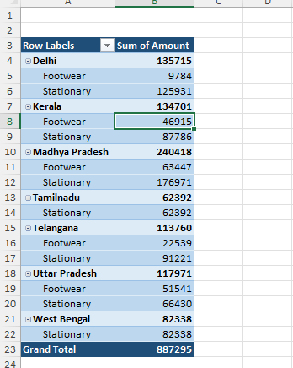



4. Create a chart showing the amount spent for each product in each city.

Answer:

